

2018
Missouri FBMA
Farm Record Analysis
Closeout Procedures

Bruce Fowler
Farm Business Management Specialist
University of Missouri
116 Gentry Hall
Columbia, MO 65211-7040
573-882-7379

Introduction

This manual was developed to assist in the standardization of data collection and entry for Farm Business Management Annual Analysis Reporting. Consistency in the data entry is the key to creating a useable set of benchmarks for producers.

Acknowledgements*

This manual was revised and edited for use in the Missouri Farm Business Management Analysis program instructors. Primary material for the revision was taken from the closeout manual written by Farm Business Management Instructors at Northland Community and Technical College in Minnesota. The original manual was developed during the Fall of 1996. It is updated annually for the Minnesota Farm Management Program by the Deans of Management, Minnesota State Colleges and Universities and the Center for Farm Financial Management, University of Minnesota.

*Used with the permission of the Center for Farm Financial Management.
Copyright © 2018 Center for Farm Financial Management, University of Minnesota and Northland Community and Technical College, Thief River Falls, Minnesota

Table of Contents

Introduction 2
Acknowledgements 2
Table of Contents 3
2018 Missouri FINAN Checklist Instructions 4-6
2018 Missouri FINAN Checklist 7-8
Input Instructions for Balance Sheets 9
Farm Assets 10-13
Personal Assets 13
Farm Liabilities 14
Personal Liabilities 15
Input Instructions for FINAN 16
Creating a New FINAN 16
General Information 17
Summary Information 17
Capital Purchases and Sales 18
Liabilities 19
Farm Income 20
Other Income 21-22
Farm Expenses 23
Personal Income 24
Other Information 24-25
Cash Flow Check 25
Labor 25
Crop Production/Livestock Enterprise (whole-farm) 26
Accrual Adjustments to Related Operating Expenses 26
Farm Interest Breakdown 26
Related Operating Expense Allocation 26
Share Rental Arrangements 26
Crop Enterprise Analysis 27-31
Livestock Enterprise Analysis 31-33
Product Sales and Other Income 34
Other Information - Livestock 34
Feed Fed 35
Direct Livestock Expenses 35
Allocated Livestock Expenses 35-36
Value Added/Nonfarm Analysis 37-38
Downloading FinPack Setup Files 38-40
2018 FBMA Price Reference 41
2018 Missouri FINAN Checklist

The Missouri FINAN Checklist has been developed to use as a tool for checking each annual farm analysis for incorrect and/or missing information. It also sets the thresholds for inclusion of farms into the state database, from which the Missouri FBMA Record Summary is derived.

A number of Missouri FBMA farms complete a “Whole Farm w/Enterprise Analysis”, while others complete a “Whole Farm Analysis” only. The farms can be included in the state summary either way, as long as they are complete in that format. Farms that complete an analysis of some enterprises, but not others, may include the completed ones in the summary as long as all data is included. Instructors should make that decision at the local level by “turning off” incomplete or mixed enterprises within FINAN before transferring it to the state office.

The 2018 FINAN checklist is printed on pages 8 and 9. Instructors may download copies in e-format or print format from adultaged.missouri.edu to use with their 2018 FINANs.

New Features / Other Reminders / Beginning of Year
What’s New for 2018?
• Market Facilitation Program – USDA FSA program for commodities directly impacted by foreign retaliatory tariffs. This payment received by producers will be entered in the whole farm analysis as “Other Government Payment”.
▪ Crop Enterprise Analysis: This payment is to be entered as “Other Income” within the crop enterprise data entry for corn, soybeans, and wheat. This will keep the payment “above the line” for cost of production calculations. This payment should not be co-mingled with any ARC/PLC payments received.
▪ Livestock Enterprise Analysis: This payment is to be entered as “Government Payments” on the Product Sales and Other Income table for the hog and dairy enterprises receiving a payment.
▪ Potential Round 2 payments or those payments not received by year-end will be entered as an account receivable on the balance sheet and will then be assigned to the correct enterprise(s) within enterprise analysis.

• Recommended procedure on how to handle trades has been updated and is found on page 19 of this manual. The recommended procedure is consistent with the taxable treatment of trades per the Tax Cuts and Jobs Act.

• Capital Purchases and Capital Sales of Breeding Livestock; Machinery and Equipment; Titled Vehicles; Buildings and Improvements; Land; Other Intermediate Assets; and Other Long Term Assets.
▪ “Purchase Price”, “Year Sold”, and “Sale Price” have been added to the detailed entry of capital assets on the Balance Sheet.
▪ Entering a “Year Purchased” or “Year Sold” and the “Purchase Price” or “Sale Price” for any intermediate or long term asset on the Balance Sheet will allow a user to select the asset purchased or sold and its value within the detailed Capital Purchases and Sales entry of the FINAN.
▪ Entering a “Year Sold” automatically removes the asset from the cost and market value total in both entry and Balance Sheet output.
▪ Added “Show sold assets” check box in all intermediate and long term asset detail. Check box needs to be selected to display the “Year Sold” and “Sale Price” columns.
▪ A listing of sold assets can be included in Balance Sheet output by going to Preview Options and checking the box for Print Sold Items by Category. When checked, an Asset Sold table is shown at the end of the Balance Sheet.
• Relaxed the rule check on balance sheet crop inventory so it no longer requires a unique description for multiple entries of the same crop and quantity.
• In detail for Cash Value of Life Insurance, added fields for “Person Insured” and “Beneficiary”.
• The Repayment Capacity calculations have been modified to more accurately reflect coverage ratios and margins for a partial-year FINAN financial analysis.
• If two 2018 FINAN’s exist in the same file, make sure that the FINAN to be added to the database is previewed or printed last.

Reminders from previous year changes
- Data entry pages for CCC Government Crop Loans have been removed from the Balance Sheet and FINAN. CCC crop loans should be entered as Current Loans, with the crop included in Crop Inventory.
- Cow-calf enterprises should include the costs of growing calves to normal “calf” sales weight
  - Calves held beyond normal calf sales weight should be transferred to a grow/finish enterprise OR should be coded with the “Cow-calf with backgrounding” special sort
  - Cow-calf enterprises with an average sales weight greater than 800 pounds will be deleted unless the above special sort is selected or a Unique Situation report indicates that the producer normally weans calves at greater than 800 pounds
- For CRP, Custom Work, Prevented Planting, and Rented Out, enter the dollars received as the production and $1.00 for the Value Per Unit. Enter the income received for Prevented Planting as Production, not as Crop Insurance Income. If forage or another product was harvested from Prevented Planting acres, include it as a secondary product or Other Income in the Prevented Planting enterprise.
- If no fertilizer was applied to soybeans, but fertilizer was applied to corn to supply nutrients for next year’s soybean, a portion of the corn fertilizer should be allocated to soybeans. The suggested allocation is 50% of the corn P & K expense.
- Adjusted family living has been eliminated. Discrepancies will now be listed as discrepancies throughout the entire report.
- New warnings for zero labor hours and zero labor and management charge.
- Refined special sort for variable rate application to identify variable rate seed, fertilizer application and chemical application.
- Be sure to add analyst name on summary page!!
- Do not change Farm ID’s on existing farms.

Other Reminders/Beginning of Year
- Be sure to delete any detail carried over from last year that isn’t used this year. Otherwise, it will junk-up your printout.
- For Value of Labor and Management, the rate for 2018 is $20,000.00 per full time operator ($10/hr.) plus 5% of value of farm production.
- Make sure you have installed the Missouri program setup. This file can be accessed and run from the electronic folder from the Winter FBMA Workshop or downloaded from the CFFM site at http://www.cffm.umn.edu/downloads/setfiles/ and must be installed on all copies of FINPACK (must be done each year, and with each FINPACK update– includes comparative graph data from Missouri and Minnesota record summaries from prior analysis years).
- On the Balance Sheet, use Expense Categories in the Detail for Prepaid Expense, Growing Crops, and Accounts Payable to identify the total expenses incurred in the Enterprise Analysis.
- For capital sales, always use Detail to enter the Balance Sheet Value of the asset sold. With this, FINAN will calculate the gain or loss on the sale.
- Enter any assets repossessed under Capital Sales detail.
- Enter Principal Forgiven under Principal Paid Detail.
- Enter Accounts Payable Forgiven under Accounts Payable Principal Paid Detail.
- Use Detail for whole farm Purchased Feed expense to list the specific feed commodities purchased. This will contribute to the Amount Available for feed in the Livestock Enterprise Analysis.
- Click the check-mark icon on the toolbar for a quick view of the cash flow check.
- Contract livestock production and livestock produced on share arrangement can be selected for any livestock enterprise on the Livestock Enterprise Analysis page.
- Make sure you delete unused enterprises (Edit + Delete Enterprise) that carried over from last year’s FINAN. Otherwise, they will junk-up your printout.
- Be more consistent in entering pasture AUMs in both crop and livestock enterprises.
Missouri Database Thresholds – for inclusion in Summary

Run the Checklist and Send FINANs by March 30.

Whole Farm Analysis
- Cash check discrepancy should be < 1% of gross income and < $5,000.
- Liabilities check discrepancy should be < $300.
- All farms must include both cost and market balance sheets.
- Total machinery and building depreciation should be <= 0. See Capital Sales and Purchases for handling gain on the sale of capital assets.
- All farms must include estimated labor hours. Even though FINPACK says this is optional, it is not optional for us.
- Farms of less than 500 hours labor and/or less than $10,000 gross farm income will not be included in the summary.

Crop Enterprises
- Rent expense should be > 0 on cash rented crops. If legitimate, enter as share rental with 100% share or delete the enterprise.
- Real estate taxes should be > 0 on owned land.
- Seed expense should be > 0 on corn, soybeans and other common commodity crops.
- Expenses should be >= 0. Negative overhead expenses are caused by over-allocating direct expenses for labor, leases, utilities and custom hire.
- Direct and CCP payments must be allocated to the cropping enterprises. For producers who did not participate, include a note on the checklist.

Livestock Enterprises
- Make sure enterprises are reasonably pure. e.g., beef calves from a cow-calf enterprise should be sold or transferred at or close to weaning weight.
- Carefully review all items in the Other Information results, such as Calving Percentage, Feed Conversion, etc.
- Enter feed quantities in the proper unit, e.g., do not enter Protein in pounds.

Family Living/Owner Draw
- If family living expenses are detailed, but detail is sketchy or only partially completed, check Delete from Summary at bottom of family living detail page.

2018 Missouri FINAN™ Checklist

Farm ID _______ - _______ - ______ Farm Name
Record Year _______ Instructor

WHOLE FARM ANALYSIS

Accuracy Checks
Cash Flow Check
1. S.P. Cash flow includes farm and non-farm income & expense, and “family living expenses reported” is accurate
- - or - -
S.P. Cash flow includes farm income & expense, and non-farm income. The resulting “adjusted family living expense” appears to be accurate.
2. S.P./Corp./Partnership - Cash Discrepancy = 0

Liabilities Check
1. Liability discrepancy = 0

Income Statement
Cash Farm Income
1. Crop & Livestock Sales quantities/numbers/prices appear to be correct. (i.e. correct units, etc.)

Cash Farm Expense
1. If “Hired labor” expense is shown, must have corresponding “hired labor hours” in Labor Summary (Production Measures Page)
2. If “Land rent” expense is shown, must have corresponding “Crop acres cash rented” in Crop Summary (exception - pasture rent)
(Production Measures Page)

Inventory Changes
1. Inventory values and changes appear to be correct.

Depreciation and Other Capital Adjustments
1. “Depreciation/cap adj” should normally be <=0 for machinery/buildings. If positive, please note an explanation on the reverse side.

Financial Statements and Measures
Profitability
1. “Change in market valuation” (line B) appears to be correct.
2. Value of operators labor & mgt. for this year is included (line D) = (Total unpaid labor hours x $10.00/hr.) + 5% of Value of Farm Production (line I). If “0” the farm should be a corporation with a wage draw.

Production Measures
Crop Summary
1. If there are beef, sheep, and/or dairy enterprises, total pasture acres must be completed.
2. If “Total acres owned” shown, then “Real estate taxes” must be included in expenses.
3. Acres under “Crop Yields” should agree w/acres under “Crop Summary.” (exc. – D.C.)

Crop Yields
1. Yields are logical.

Livestock Summary
1. Livestock efficiency factors/prices are logical.

Labor Summary
1. The labor summary is completed (not optional). Total unpaid labor hours = 2000 x FTE(s) operator labor.

Balance Sheets
1. Both cost and market balance sheets are completed.
2. Loan details on liability pages are complete. Otherwise, the term debt coverage ratio and capital replacement margin cannot be calculated.
3. Balance Sheet includes both farm and non-farm assets/liabilities.
-- or –
___ Balance Sheet is “Farm Only”.

If farm is selected as “Whole Farm” only, go to “Final Steps After Each Set of Corrections” (bottom of page).
ENTERPRISE ANALYSIS

Crop Enterprise Analysis
1. Check crop type as normal, established, double-crop, etc.
2. If irrigation expense is shown, make sure you have checked irrigation in the crop type selection area as appropriate.
3. Actual or Missouri crop value prices were used to establish product values.
4. All direct and overhead expenses are allocated and logical.
5. Real estate tax should be >0 on owned land, and 0 on cash rented/share rented crops.
6. If acres are shown as cash rented, a land rent expense must be >0. If legitimate 0, enter as share rental with 100% share.
7. There are no negative expenses. Negative overhead expenses can be caused by over-allocating direct expenses for labor, custom hire, etc.
8. Government payments have been properly allocated. LDP payments are generally included in “Value per unit” or “Other income.” Direct and counter-cyclical payments are entered as “Government payments” in Other Crop Information.
9. Crop and pasture acres added together equal total farm acres minus non-productive and double-crop acres.
10. Crop enterprises are established for CRP and rented land. Total production = CRP payment or rental payment and Value per unit = $1.00. Expenses are allocated as appropriate.
11. AUMs are calculated for pasture by the “1000# animal unit/month method.”
12. Crop enterprises that are mixed or inaccurate (unusable in averages) have been turned off. (Done in the “Other Crop Information” screen “Delete from Summary”)

Livestock Enterprise Analysis
1. Quantities, prices, units are logical.
2. All direct and overhead expenses are allocated and logical.
3. “Cull sales” are not also shown as “Capital sales.”
4. Efficiency factors and production figures are logical.
5. Feed record is complete. Pasture AUM’s are included on beef/dairy/sheep enterprises. (should equal pasture produced unless some is rented out)
6. There are no negative expenses.
7. Livestock number balance = 0 or 1.
___8. Beef calves from a cow-calf ent. should be sold or transferred at or close to weaning weight.
9. Livestock enterprises that are mixed or inaccurate have been turned off. (Done in the “Livestock Enterprise” screen “Delete from Summary”)

Crop & Feed Check
1. Quantities are in balance. (Exception: home seed used).
Contributions to Overhead
1. Enterprise returns and net farm income are reconciled as follows: If all applicable income and expenses have been allocated, the total of net returns from each enterprise plus non-directed government payments (or total return over overhead exp) should approximate net farm income

Final Steps After Each Set of Corrections:
Run “preview” - otherwise the data file to be transferred will not be updated. To preview “comparative” pages, must turn them on under “preview options”.
Make corrections to clear any errors and re-run the checklist.
When the FINAN file is clean, prepare and transfer as follows:
1. On “General Information” screen, check (✓) “Analysis complete, include in RankEm group summary” (unless there is some reason it shouldn’t be, and please note why below).
2. Complete the “Summary Information” screen. All information blanks must be completed including “analyst name” and “summary group”. Use first 6 digits of farm number for Farm ID. If no acres are owned use “0”.
3. Run “preview” for final update to file.
4. E-mail the FinPack data file with no extension or the “.FPD” extension (File type “FINPACK Document”) file along with a completed FINAN checklist to fowlerb@missouri.edu Large files may need to be zipped (compressed) before sending. Please do not send an opened file, as I receive it locked and have to go through an unlocking procedure.
Notes and explanations concerning this FINAN:

Input Instructions for Balance Sheets

Building the FINPACK Balance Sheet for January 2019. You can either “Create a blank balance sheet” and start from scratch or you can “Create a balance sheet with a copy” and use last year’s entries as a guide for this year. You will need to “date” the new balance sheet. If you used “January 1, 2018” as last year’s date, use “January 1, 2019” as this year’s date. Be consistent from year to year.

On balance sheets, we recommend starting with a copy of last year’s sheet, since many of the entry items are repetitive. However, care must be taken to go page-by-page to make certain all items are updated or deleted. Otherwise, it is easy to leave some old information that should be changed or deleted.

If you copy balance sheets forward, remember that “detail” is carried forward (e.g. the year date in figuring accrued interest on loans must be changed to avoid an error).

NOTES: The Schedules included with the FINPACK Balance sheet are a tremendous help in reminding the user to be as complete as possible. Please list all assets, and cost value and market value, where appropriate.



Valuation Method: Select “Both” during entry; you can still choose to print only the Market Value or Cost Value by selecting these later when you print.
ASSETS:
Current Assets:

Cash and Checking Balance: Includes all farm accounts, savings and checking, CD’s (Certificates of Deposit), money market accounts, etc. Use Detail or double click in the entry box to make a detailed list.
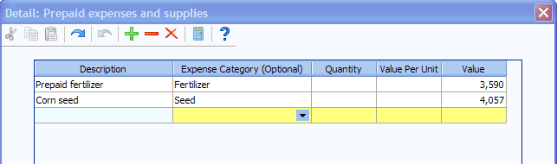

Prepaid Expense and Supplies: Include: paid fuel, fertilizer and chemical in tanks,
fall applied fertilizer and/or chemicals, prepaid accounts at elevators, co-ops, companies, etc. Accumulate expenses related to planting cover crops for soil nutrient enhancement using the Cover Crop Expense category.
Lime fertilizer expenses should be a prepaid expense. The expense should then be allocated to the respective field/crop for a subsequent number of crop years, per the operator’s discretion. Use Detail to select the expense category to help identify the total expense incurred in the FINAN enterprise analysis.

Growing Crops: Example: Winter Wheat (cost of inputs). Expenses related to planting cover crops for sale or feed use should be considered a growing crop. Use Detail to select the expense category.

Accounts Receivable: Examples: Insurance payments, money owed from others, etc.; estimated Disaster payments to be received next year, LDP’S where paperwork is done but the check is not received (corn silage). Deferred crop sales may be included in Accounts Receivable or as crop inventory. Use Detail in the entry box to enter a detailed list.

Loan repayment rate locks: If the producer has a marketing loan repayment rate lock in place as of January 1 and the market price is higher than the repayment rate, show the equity gain as an account receivable.

Hedging Accounts: Enter the Net Liquidity from the year-end brokerage statements.

Other Current Assets: Enter any item not fitting the categories listed in the Current Assets section of the Balance Sheet.

Crop Inventory Always enter the Quantity, Value/Unit and Value. Enter crops under CCC loan as normal crop inventory, valued at market value or loan rate, whichever is higher. If the market price is below the loan rate and an LDP has not been claimed, value the crop at local loan rate. If the price has been locked in, use that price less estimated storage costs until delivery. Refer to the 2018 FBMA Price Reference on the last page of this manual for recommended inventory prices. For year-end advances on crops sold for the following year, convert the dollars received on the advance to units of crop based on the percentage of the sale received. Reduce the grain inventory by this number of units. Price used in the calculation for determining bushels should be the underlying contract price.

- Note - Crops left standing in the field: Segregate this crop on a separate line of crop inventory on the ending balance sheet. Enter a description to identify it as still in the field. Use a conservative estimate of production valued at the normal inventory price. On the liability side, add clearly labeled accounts payable to reflect estimated harvesting costs. This will allocate the harvesting costs to 2018 enterprises rather than 2019.

Livestock Held for Sale: Include Feeder Animals intended for eventual sale.

Intermediate Assets:

Breeding Livestock: Include all breeding females and males. To-be-culled breeding animals remain as intermediate livestock until sold. Cost value for raised livestock should be set initially as the estimated cost of production (base value) and should remain the same throughout the life of the animal. Purchased animals should be separated from raised with cost value being the purchase cost less depreciation down to the base value. They should generally be depreciated to the base value in 3 years or less.

Farm Machinery and Equipment: Enter both the Market Value and the Cost Value. For cost valuation, use an economic depreciation method that reflects the estimated actual useful life of the asset or group of assets. An easy calculation is to subtract 5 to 15% of the remaining cost value each year. We recommend entering a detailed list of all machinery & equipment owned, rather than just using a total figure.

Start new machinery at full purchase cost for both cost and market value and depreciate depending on use during the year.

For new cooperators, establish the cost value of existing mach/equip by creating a detailed list and estimating the purchase cost less economic depreciation on each item. If this is unworkable, begin at market and apply economic depreciation in future years.

Use the Detail to enter a detailed list. Use the Adjust Values (%) feature to do a percentage depreciation on selected items in the detailed list.

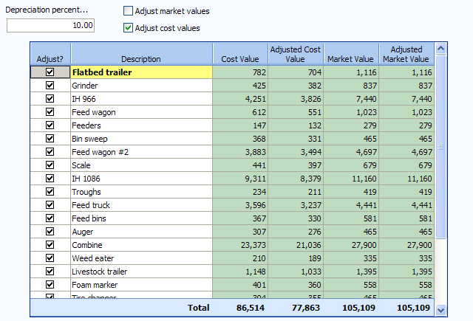

Suggested Depreciation Rates

Livestock equipment 5 - 20 %
Crop machinery 7 - 15 %
Buildings and bins 5 %
Augers and movable equipment 10 %
Vehicles 10 – 20 %
Office Equipment 30 %

Titled Vehicles: If desired, separate titled vehicles from farm machinery. For analysis purposes, machinery and titled vehicles will be added together to calculate Machinery Depreciation.

Other Intermediate Assets: Example: Cooperative Stock, (this is not to be confused with co-op patronage equities which are long term assets), such as Farm Credit Services stock. Enter the retained value for each co-operative separately. For the market column, value stock at market value with recognition of changes if significant changes in valuation have occurred since the beginning of the year. Use Detail to enter a detailed list.
Long Term Assets:

Farm Land: Use Detail to enter the Acres, Value/Acre, Cost Value
and Market Value. Do not change the Market Value unless a significant change occurs.

For new cooperators, the cost value of farm land should be the purchase price minus the value of residence, buildings, and other attached assets that will be valued separately. The cost value of a given piece of land should not be changed. The total purchase price of the farm should equal the initial cost values of the land and all attached assets.

- Note - Entering Values of Inherited Land on the Balance Sheets and FINAN - On the cost balance sheet, enter as an asset at received tax basis value. Value on the FMV balance sheet as is appropriate. On the FINAN, enter as land purchase at the received tax basis value, then enter an identical amount on Non-farm income screen as “gifts and inheritances”. Other inherited property would be handled in like fashion.

Farm Buildings: Enter both Cost Value and Market Value. Use a Management Depreciation Method which depreciates the original cost over the life of the asset for the cost value. An easy calculation is to subtract 5 to 7% of the remaining cost value each year.

Enter new buildings at original purchase cost for both cost and market value and depreciate based on use during the year. Use the Detail to enter a detailed list.

Other Long Term Farm Assets: Enter any long term asset not already categorized
above, both Cost and Market Value.(e.g., Co-op equities)

Capital Purchases & Capital Sales: Details regarding the purchase and sales of Breeding Livestock; Machinery and Equipment; Titled Vehicles; Land; Buildings and Improvements; Other Intermediate Assets and Other Long Term Assets can be recorded on the Balance Sheet. Use Detail to enter this information. Then, the details of these transactions for the year can be selected within Capital Purchase and Sales entry in the FINAN. “Show sold assets” check-box is available in all intermediate and long term asset detail. Check-box needs to be selected to display the “Year Sold” and “Sale Price” columns. The correct entry of traded assets can be found on page 19 of this manual.
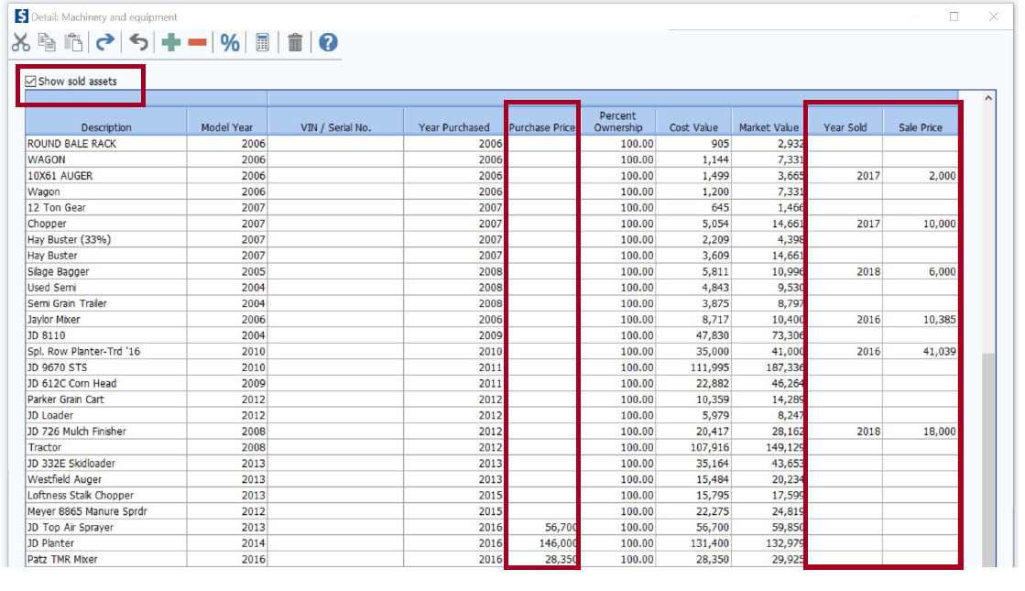

Personal Assets: These should be detailed as well. Enter the residence in this category. The cost value of a residence should not change unless real improvements are purchased and made. The market value of the residence should only be changed when a significant change in value occurs.

LIABILITIES:

Current Liabilities:
Accrued Interest: Sum total of all of the unpaid accrued interest from current, intermediate and long term loans. Includes past due and interest since last payment. FINPACK will calculate this according to the interest percent, loan balance, and date of last payment reported in the loan section. This is only reported in the output.

Accounts Payable and Usually includes accounts payable, charge accounts, such as feed,
Other Accrued Expense: fertilizer owed to local businesses, real estate taxes owed but not
paid (advised to list all separately). Do not include credit card or FarmPlan balances if expenses are included in outflows—include in current notes instead. Use detail to list each account and the Expense Category to assist in enterprise analysis allocations.

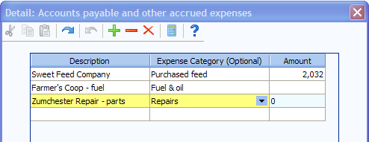

Current Loans: Loans due in less than 1 year. If expenses financed by credit cards or FarmPlan are included as outflows in FINAN, include balances as a Current Loan here. If not, include them in Accounts Payable.

Intermediate Loans: Debt owed on equipment and livestock; usually ten
years or less. P&I payment is required for calculation of Term Debt Coverage. Principal due is amount due in that 12-month period.

Note on Capital Leases:
If this is an operating lease (the operator’s intent is not to eventually own the asset), do not enter the asset or liability on the Balance Sheet.

If this is a capital lease, which includes a “buy-out” provision:
- Report the asset value in the appropriate asset category and depreciate on the cost balance sheet.
- Report the lease as a liability with interest and a payment separated by principal and interest.

Long Term Loans: Loan of longer than ten years ~ usually real estate (land or buildings). P&I payment is required for calculation of Term Debt Coverage.

Personal Liabilities: All liabilities that are non-business or non-farm accounts payable and other accrued expense.

Personal Accounts Payable: Income and self-employment taxes should be estimated and included as personal accounts payable. Be sure to have the entry on both the beginning and ending Balance Sheets. List credit card balances as accounts payable if they are not included as cash outflows in FINAN.

Personal Loans

Personal, Current Loans: Short term loan due 12 months or less. Include credit card balances if included in cash outflows in FINAN.

Personal, Intermediate Loans: Car loans, boats, furniture and other personal items.

Personal, Long Term Loans: Real estate, house, cabin, trailer house.

Deferred Liabilities: The Missouri Adult Agriculture Instructors made the decision as a group not to emphasize the use of deferred liabilities on market balance sheets at this time, but to maintain conservative market asset values instead. Some cooperators may desire placing a “deferred” or “contingent” liability value on their balance sheets, and it would be entirely appropriate to do so. The purpose of tracking deferred liabilities is to provide an accurate financial picture, should a farm business be liquidated.

- Note on Farm Liabilities – Handling loans from institutions where producers may not receive deposit slips or write checks on their own account on a regular basis can be confusing. Often, the loan payments are made directly to the lender by companies the producer markets commodities or services through, and a check or deposit slip may rarely pass through the producer’s hands.

Even though the farmer may never have run any money through his account or made any payments personally, the principal amount of the loan should be shown as money borrowed on the liabilities pages of the balance sheets and FINAN. Remember that all intermediate and long term liabilities and current liabilities that extend through the beginning or end of year must be entered on the balance sheets first. Then, as payments are made by the farmer or companies he is producing for, those payments should be reflected on the liabilities pages of the FINAN, so that at the end of the year, the principal remaining on the loan on the balance sheet is correct, and the FINAN reflects the money borrowed and principal paid for the year. Also, any excess money being held in loan escrow accounts at the year’s end should be included on the balance sheet as an asset.

INPUT INSTRUCTIONS FOR FINAN

CREATING A NEW FINAN

In all areas where you wish to detail, use the Details button or double click in the entry box to do so. Many times it is helpful. Dark blue background in cell indicates box has detail.

Data File Name: Use the nine-digit FBMA farm number for the filename as follows: 000-000-000 (identifier). The identifier can be the name of the farmer, or farm or anything else that identifies the farm for the local adult instructor. It will be very helpful to troubleshoot data problems if you will use this format for all farms’ filenames, and be consistent with it.

The analysis name must be entered on this screen. It can be changed on the “File Navigator” screen if need be later. Recommendation; (”year” Analysis)

If possible, copy the previous year’s analysis and check “Clear out general data and prepare for another year.” All data will be deleted except:

- General Information and Summary Information input screens remain unchanged. The Balance Sheets from last year remain selected; you need to select the appropriate Balance Sheets for this year.
- All “detailed” values are deleted but the descriptions remain. It will be important to delete any of these detail descriptions that aren’t used as part of this year’s FINAN, so they don’t show up on the printout and junk it up.
- Value of Labor and Management remains (Other Information page).
- Labor hours remain.
- Related Operating Expense Allocations to Crops, Livestock, and Other Enterprises remain.
- Crop names, descriptions, and acres stay in the Crop Enterprise Analysis.
- The Default Allocations stay in the Allocated Crop Expenses.
- Livestock names and descriptions remain.
- Individual feed items remain, but quantities and dollars are cleared.
- The Default Percentage Allocations stay on the Allocated Livestock Expenses page
- Other Livestock Information such as; average number of head, normal total gain per head, barn capacity, or number of litters remain.
General Information

- Enter analysis year.
- Identify Type of Analysis, whether “Whole Farm” or “Whole Farm with Enterprise Analysis”
- Check “Show Group Summary Information”
- When you have completed the analysis, check “Analysis complete, include in RankEm” unless there is a valid reason it shouldn’t be.
Summary Information

- Select proper type of business organization

- Enter the first 6 digits of the producer’s farm number. If you do not know the farm number, or need a number for a new cooperator, call or e-mail Mandy in the state office. This is necessary to keep from having duplicates, etc. (573-882-7379 or aholtml@missouri.edu ).

- State and County - Enter State and County name from pick lists.

- An operator is generally defined as one family that relies on the farm for family income and receives that income in the form of farm earnings (or owner wages in the case of a corporation). A husband and wife unit is generally considered one operator. Additional family members or partners are operators if they are not paid labor. It is possible to enter decimals for part-time operators but unless the producer spends less than 50 percent of his/her time on the farm, the farm should indicate at least one operator.

- All data is required by RankEm. Be sure to enter Acres Owned, Number of Operators to the tenth, Primary Operator Year of Birth and Years Farming.

- Special Sorts: The Missouri FBMA program is not using any special sorts at this time.

- Analyst Name: Put the name of the person completing the analysis (instructor name).

- Summary Group: Select “Missouri Farm Business Management Analysis” from the drop down menu.
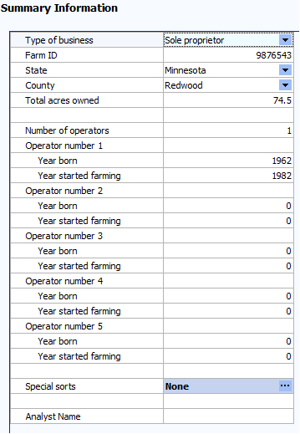
Capital Purchases and Sales:

- Beginning Values and Ending Values are brought forward for reference by computer from the Balance Sheets.

- Enter Capital Purchases and Capital Sales. For capital sales, always use Detail to enter the Balance Sheet Value of the asset sold. With this, FINAN will calculate the gain or loss on the sale. Selecting the “Select from Balance Sheet Items” icon from the toolbar in Sales and Purchase detail will allow you to bring purchases and sales entered on the Balance Sheet into the FINAN. (This applies to Machinery and Equipment; TitledVehicles; Land; and Buildings and Improvements.)

To select items from the Balance Sheet to include in the FINAN, the user must be in the correct capital asset cell in the table to bring in purchases or sales of that asset type. By checking the “Include” box, the assets will automatically be brought into detailed entry.

By checking “Include” and pressing the “Close” button, the assets will be brought into detailed entry.

- Enter any assets repossessed under Capital Sales detail.

- Breeding Livestock ~ Be sure you don’t enter sales both here and on Cull Breeding under “Other Income.” Recommendation: Enter whole herd liquidations and major herd reductions here and enter normal cull breeding livestock sales under “Other Income”.

- Other Intermediate Assets ~ Include new generation coop stock purchases and sales. Be sure to include changes in PCA or FCS Stock as a purchase or sale as appropriate.

- Other Long Term Assets ~ Be sure to include Patronage, stock redemption or retirement as a sale.

- Personal Capital Purchases and Sales ~ All purchases of nonfarm capital assets should be listed in the proper category. Premiums on whole life insurance policies should be included in nonfarm capital purchases.
Recommended procedure for trade-ins:
- The capital purchase will equal cash (boot) paid plus the sale value received for the traded asset. This value will also be entered as the cost value of the newly acquired asset on the Balance Sheet.
- The sale amount entered on the Balance Sheet and in FINAN will equal the value received for the traded asset from the dealership or other purchaser.
- In FINAN, the amount entered as the “balance sheet value” is the cost value of the traded asset. If using “Select from Balance Sheet items” feature, FINPACK will automatically enter the cost value coming from the balance sheet for the traded asset.
- Market value of the newly acquired asset equals the estimated current market value.
- If sales details are entered on the Balance Sheet for the traded asset, the item can remain on the balance sheet. Entering sales this way removes traded/sold item from the printed asset list and the value of the traded/sold asset is removed from the total cost and market value of the asset group.

Farm Current/NonCurrent & Personal Current/NonCurrent Liabilities

- Beginning and Ending Principal Balances are displayed from Balance sheets.

- Enter Money Borrowed and Principal Paid for each loan.

- Enter Principal Forgiven under Principal Paid Detail.

- Enter Accounts Payable Forgiven under Accounts Payable Principal Paid Detail. This is the only entry allowed for Accounts Payable.

- New Loans. Enter loans taken this year as money borrowed.

- Under each loan type or by individual loan, check liability balances as follows:

Beginning Balance + Amount Borrowed - Principal Paid = Ending Balance

FARM INCOME:

Crop Sales ~ Enter per crop; gross quantity of crop sold and gross income received. Include gross sales of crops that were under CCC loan. Do not include money borrowed on CCC loans and treated as income for tax purposes. Include the funds received for yearend grain advances as a grain sale in the year received. All yearend grain advances should be treated as a crop sale, and not as other income. Use underlying contract price to determine bushels.
- If you make gifts of grain or livestock
On the Whole Farm Analysis - record value of gift as sale of grain or livestock, and record same total as cash gifts given on Other Information input page.

On the Whole Farm w/Enterprise Analysis - handle same as whole farm, plus record as grain or livestock produced and sold on the enterprise input pages.

- If you make deferred sales of crops - enter bushels/tons and dollars as crop inventory on ending balance sheet. Next year, it will be shown as a crop sale with the same units and dollars.

Livestock Sales ~ Enter number sold, total live weight pounds sold, and gross income received of market livestock. Record cull breeding livestock in Cull Livestock section, not here.
(To calculate swine live weight on grade and yield, divide the carcass weight by the yield, recommended yield 75%. For cattle, recommended yield 62%)

- Livestock butchered for home use:
On the Whole Farm Analysis - record the value of animal(s) butchered as Animal Sales, and record the same amount as Family Living expense.

On the Whole Farm w/Enterprise Analysis - handle the same as whole farm, plus record on Livestock Enterprise page as “Butchered”.

- If you make gifts of grain or livestock
On the Whole Farm Analysis - record value of gift as sale of grain or animals, and record same total as cash gifts given on Other Information input page.

On the Whole Farm w/Enterprise Analysis - handle same as whole farm, plus record as grain or livestock produced and sold on the enterprise input pages.

- If you make deferred sale of livestock (2 options)
Option 1 - Enter lbs., nos. and dollars on closing livestock inventory on the ending balance sheet. Next year, it will be shown as a livestock sale with the same units and dollars.

Option 2 – Record on ending balance sheet as accounts receivable in assets.
Record on enterprise analysis as numbers, lbs. and dollars sold.

Livestock Products ~ Enter gross quantity and gross income received.

Other Farm Income

Cull Breeding Stock ~ Enter normal income received from Cull Breeding Stock on income statement. It is recommended that breeding stock sales should be entered as capital sales only when liquidating a herd or doing a major downsizing. Use Detail to allow selecting the data into the Enterprise Analysis.

Miscellaneous Livestock Income ~ Enter any miscellaneous livestock income.

LDP Payments ~ Include all LDP Payments received during the Analysis Year.

Crop government payments ~ ARC and PLC payments present a special problem because the payment amount is not known until the end of the marketing year. This uncertainty makes it impossible to accurately match income to the production year. Therefore, it is recommended that ARC/PLC payments be recognized as income in the year received rather than trying to estimate the amount that should accrue to each production year.

CRP Payments ~ Enter all cash CRP Payments received in the analysis period.

Livestock Govt Payments ~ Include dairy payments as well as any other livestock related payments.

Other Government Payments ~ Enter any other government payments, such as disaster payments, EQIP reimbursements, CSP payments, etc. Market Facilitation Program – 2018 USDA FSA program for commodities directly impacted by foreign retaliatory tariffs. This payment received by producers will be entered as “Other Government Payment”.

Custom Work ~ Enter all cash farm related custom work income.

Patronage Dividends ~ Enter all cash patronage dividends and cash unit retains received. Additional stock accumulation should be recorded on the Balance Sheet.

Insurance Income ~ Enter the gross cash for all insurance income payments.

Cash Withdrawn from Hedging Accounts ~ Enter all cash withdrawn from hedging accounts.

Other Farm Income ~ Enter all cash farm income not previously entered.

- Special Note for EQIP and Other Cost Share Payments: It is recommended that cost-share for feedlots and other large capital purchases be entered in the following manner to minimize distortion of net farm income and enterprise profitability. Enter the total cost as a capital purchase and the cost-share portion as a capital sale. On the ending balance sheet, the cost value of the asset should reflect the total purchase amount less the government cost-share payment, less the appropriate amount of depreciation for the year. The market value should reflect the full asset value. This will balance the cash flow but will exclude the cost share payment from net farm income without distorting depreciation.

Example: If the total cost of a feedlot is $100,000 and government cost-share is $48,000, then $100,000 should be entered as capital purchase (buildings and improvements) and $48,000 as capital sale. The ending cost value of the feedlot on the balance sheet is $49,400 ($100,000 minus $48,000= $52,000 *95% to depreciate over 20 years). The market value should be the estimated amount by which the addition of the feedlot increased the market value of the property on which it was built.

- Special Note for ethanol plant and other entity investments: Payments and/or expenses related to ethanol plants and other entity investments may have a significant impact in certain years. It is left to the producer/student and instructor to decide whether these transactions result in farm (or non-farm) income. Treatment should be consistent from year to year and should be consistent with treatment of the business investment on the balance sheet. Whether farm or personal, these transactions should not substantially impact crop and livestock enterprise returns. The profitability of specific value-added enterprises should be evaluated using the Value Added/Non-Farm Enterprise Analysis.

- Special note on hedging transactions: If you do not have accurate record of cash deposits and withdrawals, the net cash transactions for the year can be calculated from Forms 1099: The net deposits/withdrawals = Form1099, enter Box 11 + beginning balance sheet value – ending balance sheet value. If the result is positive, enter as income (cash withdrawn from hedging accounts) and if negative, enter as an expense (hedging account deposits).

FARM EXPENSES:

Direct Crop Expense/Direct Livestock Expense/Related Operating Expense ~ Enter all
actual cash farm expenses paid during the calendar year.

Note: Include all expenses for trucking, commission association dues, and marketing fees that are deducted from gross sales of grain, livestock, or livestock products as long as the gross receipts were included in income.

- Free seed, chemicals, etc: enter as Other Farm Income and Seed/Chemical/etc. expense;
- Fertilizer and chemical application: Custom Hire;
- Employee benefits: Hired Labor;
- Precision farming expenses: if they do not fit elsewhere, include in Misc. Crop Expense.
- DHIA: This expense will be listed if you have downloaded the Mo FINPACK setup files;
- Cash salaries, wages, and benefits to operators: Enter in Owner Wages and Benefits and adjust Value of Operator Labor and Management appropriately;
- Precision farming expenses: If they do not fit elsewhere, include in Misc. Crop Expense;
- Cover crop expenses for agronomic soil enhancement: Cover Crop Expense;
- Feed additives: Purchased Feed;
- Livestock implants: Veterinary;
- Manure handling: Custom Hire if hired;
- Hoof trimming – Custom Hire;
- Milk hauling – Trucking and Hauling.

Use Detail for Purchased Feed to specify the feed commodities purchased which will then contribute to the Amount Available for feed in the Livestock Enterprise Analysis.

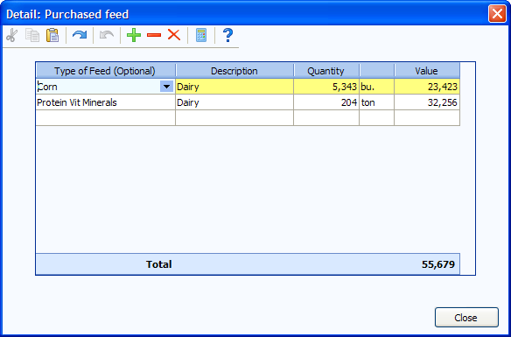

Use Detail to list interest paid on individual loans. This will automatically transfer to the interest breakdown on the enterprise analysis. Do not include interest on CCC loans as it will be calculated from the Government Crop Loans entries.

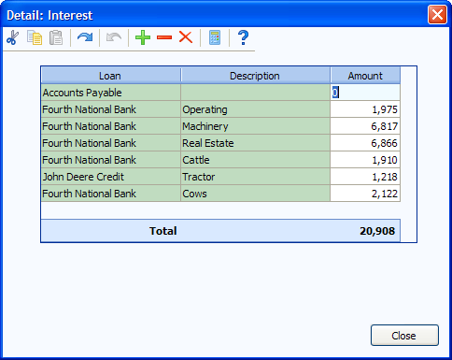

Personal Income

Enter all cash non-farm income received during the analysis period.

Warning: Do not double count dividends, tax refunds that may have been farm
income such as gas tax refunds, property tax refunds, etc.

Other Information

Gifts and Inheritances ~ Enter cash gifts and cash inheritances received. For non-cash items, enter the value as a capital purchase and offset the purchase by also entering the value here.

Family Living Expense ~ Enter cash family living expenses including personal share of utilities, insurance, property taxes, and any other such expense. The total expenditure should be tracked for each sole proprietorship, whether or not detailed family living expenditures are recorded. If Detailed family living expenses are entered, be sure to enter the number of family members. If family living expenses are only partially detailed, be sure to check Delete from summary at the bottom of the detail list. Enter owner wages as farm expenses, not owner withdrawals. For partnerships, use detailed family expenses or enter total under partnership withdrawals detail item, not both.

Income and Social Security Tax Paid ~ Enter all cash income and personal self employment taxes paid during the calendar year.

Cash Gifts Given ~ Enter all cash gifts given.

Estimated Value of Labor and Management ~ This is the opportunity cost charged for unpaid operator labor and management when calculating the Rate of Return on Assets and Rate of Return on Equity. It is also combined with any Owner Wages and Benefits expense and deducted from the enterprise analysis reports. In the RankEm Summary reports it is always combined with Owner Wages and Benefits to make farms of different ownership structure comparable. For sole proprietors and partnerships, figure at: $20,000/full time operator plus 5% of value of farm production. Divide hours of unpaid operator and family labor from labor page by 2000 to get operator’s FTE’s. For less than full-time operator, figure $10.00 per hour operator labor plus 5% of VFP.
Other adjustments:
- For corporations, if owner compensation is included in Owner Wages and Benefits expense, enter zero.
- For sole proprietors and partnerships, if any compensation is included in Owner Wages and Benefits, reduce Value of Labor and Management by the same amount.
- Wages paid to children and other family members (other than operators and their spouses) who have no at risk capital investment and do not share in profits should be included as hired labor expense and have no effect on this entry.

CASH FLOW CHECK
At any time during data entry, click the check-mark icon on the toolbar to view the cash flow check.

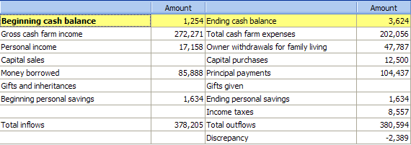

Labor

– 2000 hours of labor per full-time unpaid operator is recommended. Include unpaid family labor and part-time unpaid labor as appropriate. For example, if one spouse contributes ¼ FTE to the business and the other spouse contributes ¼ FTE to the business, the total would be 1000 hours unpaid operator and family labor. In addition, just because an operator may not be employed off the farm or may be retired, one shouldn’t assume he is “full-time”. Consider hours worked in productive farm work in making this determination. Also, consider the acres of crops, units of livestock, etc. in making this determination.

This input is critical to the analysis in a number of ways, but particularly in making the analyses comparable in the data summary.

If a corporation or partnership pays owner wages as part of the farm expenses, the corresponding hours should be inputted as “full-time” or “other” hired labor in the labor input screen.

Crop Production/Breeding Livestock Record (whole-farm only) – These screens should be completed with basic enterprise information if the analysis is going to be whole-farm only.

Accrual Adjustments to Related Operating Expenses

This section makes adjustments to the cash expenses to arrive at the amount actually incurred for the analysis year. Recommendation: Enter the detailed expense categories for prepaid expenses, growing crops, accounts payable and accrued interest on the balance sheets to automatically complete this page.

Farm Interest Breakdown - Enter interest accrued during the calendar year. When detail is used for farm interest expense input, the amounts automatically move to this location, therefore, you do not have to input them here.

Cash Interest Paid + Ending Accrued Interest - Beginning Accrued Interest = Interest on Debt. Interest on Debt needs to be allocated to operating, intermediate and long term.

Related Operating Expense Allocation

Enter the proportion of the total for each allocated expense to crop, livestock, and other (value added/non-farm) enterprises. Toggle to enter dollars instead of percentages

Note: To maintain meaningful trends, attempt to be consistent from year to year unless
there are major changes to the farming operation. The average for power and
machinery is 75% - 80% to crops, for building and fences is 30% - 35% crops.

Share Rental Arrangements - Select whether the operation being analyzed is the Renter or Landlord . Then enter their share of the production and expenses.

Zero Cash Rental Arrangements - If a producer rents land for zero cash rent, enter as a 100% share arrangement with the renter paying 100% of all expenses.

More than one Share-Rental Arrangement in which the renter receives the same percentage of production - If you use more than one share-rental arrangement in which the renter received the same percent of production, you use the pick list under “Your Share” on the Crop Enterprise Analysis page to specify which arrangement is to be used.

Crop Enterprise Analysis

Crop Name ~ Use the crop list (“Down arrow” Pick List). If you want to use a crop that is not listed, contact Bruce or Mandy for assistance in adding one. User added crops, or those that are not in the FINPACK crop list, will not be included in summary reports.

- For all types of grass and mixed hay, Missouri analyses should use the “Mixed Hay” enterprise if they want the enterprise to be included in a Missouri hay summary.

- For haylage and other wet forages other than corn silage, it is recommended but not required that the dry hay crop name be used and the forage production be converted using the formula under Total Production, found later in this discussion.

Description ~ You may use this to further describe the crop or field. Be consistent. You can now use this description with the historical database to identify specific farms or fields. For “small grain hay” use the description to identify barley, oats, and mixed.

Crop Type ~ Use only if applicable. The default is normal crop.

- Hay establishment should be entered separately from full production hay and coded establishment. If seeded with a cover crop such as oats, enter the alfalfa in a separate column from the cover crop and code it establishment/double crop. (The cover crop should be left as normal) Use your judgment in allocating seed, fertilizer and other direct expenses between the enterprises. Reduce the overhead allocations so that only one acre of expense is allocated to the two enterprises.

- Be sure to code irrigated crops – they should not be summarized with dryland acres.

Acres Owned ~ Either total crop or each field owned.

Acres Cash Rented ~ Either total crop or each field cash rented.

Acres Share Rented ~ Either total crop or each field share rented.

Your Share ~ Must choose a % production from the crop share rental arrangements. (100% if owned or cash rent.)

Total Production ~ Bu, Cwt, Tons and total volume produced for this field or crop (your share).

- Convert haylage to dry hay equivalents using the following formula
- (% dry matter of wet crop ÷ % dry matter of hay equivalent) * wet production
- Example for converting 100 tons of haylage:
(.50 dry matter haylage ÷ .85 dry matter hay) * 100 = 58.8 tons

- For CRP, Custom Work, Prevented Planting, and Rented Out, enter the dollars received as the production and $1.00 for the Value Per Unit. Enter the income received for Prevented Planting as Production, not as Crop Insurance Income. If forage or another product was harvested from Prevented Planting acres, include it as a secondary product or Other Income in the Prevented Planting enterprise.

- Convert high moisture corn to dry corn equivalent.

- For pasture, estimate production in AUMs based on these animal units:

1000 lb. Cow/calf 1.00
1100 lb. Cow/calf 1.07
1200 lb. Cow/calf 1.13
Mature bull 1.30
Calves by themselves 0.30
Weaned calves to yearling (400-600 lbs) 0.30 - 0.60 depending on feed supplement
Yearling cattle (600-800 lbs) 0.50 - 0.75 depending on feed supplement
2-year old cattle 0.85
Dairy cow 1.30
Ewe/lamb pair 0.20
Mature horse 1.50
Mature meat goat 0.20

For example, if a pasture enterprise fed one hundred 1100 pound beef cows for six months, enter 642 aums (100 cows x 1.07 animal units x six months). This same amount should be entered as feed fed to the beef enterprise analysis.

Value Per Unit ~ For crops already sold or contracted for sale enter the actual sale/contact price. For crops in inventory, use the ending inventory value with a minimum of the loan rate for program crops. For crops already fed, use a conservative sales value and use this same value for valuing the feed in the Livestock Enterprise Analysis. Forage values should reflect relative feed value (RFV) and be based on estimated sales value, not purchase prices. Refer to the Missouri 2017 Price Reference on the last page of this manual for recommended prices when actual values are not available.

- If you make gifts of grain --
On the Whole Farm Analysis - record value of gift as sale of grain, and record same total as cash gifts given on Other Information input page.

On the Whole Farm w/Enterprise Analysis - handle same as whole farm, plus record as grain produced and sold on the enterprise input pages.

Other Crop Income ~ Allocate hedging gains or losses, crop insurance income, LDP payments for this year’s production, crop government payments (ARC and PLC), and any other crop related income. Examples are straw sales, crop specific disaster payments, and hauling allowance. Enter Detail to document what was included. Use the –X method to allocate across like enterprises (see Direct Expenses below).

Special notes:
- Because of the uncertainty of ARC and PLC payments, Crop Government Payments should be allocated to the year received rather than the production year.

- Allocation of Government Payments:

- ARC and PLC payments are entered here but are included in the output report as a “below the line” adjustment, meaning they are added to the net return at the bottom of the output report. Use your discretion to allocate payments to crop enterprises. Allocate by farm unit if possible. If crop rotations have not changed substantially since bases were established, payments can be allocated to program crop acreages only. If crop rotations have changed, it is recommended that payments be allocated over all tillable acres. Whether hay and pasture acres are included should probably depend on whether they were used or usable in determining payment history.

- Market Facilitation Program payments are entered as “Other Income” for corn, soybeans, and wheat. This will be keep the payment “above the line” for cost of production calculations. This payment should not be co-mingled with any ARC/PLC payments received. Round 1 payments not yet received by year end, as well as Round 2 payments, if announced, will be entered as an account receivable on the balance sheet and should also be distributed to the correct enterprises within enterprise analysis.

- CSP payments: Because these are often very large payments that may impact a limited number of acres, including these payments in enterprise income will often distort enterprise returns. Therefore, if you choose to include these payments, please mark impacted enterprises to be excluded from the database.

Direct Crop Expenses ~ Expenses (accrual basis) for this crop. For like enterprises that share the same input cost per acre for a specific input, you can enter the total cost for a Direct Expense category (fertilizer) in one column (1). You can then assign it equally to the other fields using a “-1” in the new enterprise(s). The “-X” indicates the column location of the first enterprise. (Crops do not have to be listed side-by-side for this to function properly.)

Seed ~ Seed expense (may include seed treatment). Assign a realistic expense for home-grown seed used. (Usually market price, plus cleaning treating and hauling).

For hays, seed expenses should appear only on establishment enterprises and not on the full production enterprises unless there were re-establishment costs. If re-establishment occurred, make a note on the FINAN checklist.

- When using home-grown seed:
On the Whole Farm analysis, no transactions are needed. The grain used for seed comes from last year’s crop and the inventory reduction resulting from the grain used for seed will be offset by the corresponding reduction in seed cost.

On the Whole Farm w/Enterprise analysis, again, no transactions are needed on the whole farm input. However, on the crop enterprise input, record the value of the grain used for seed as seed cost on the crop enterprise input page.

Fertilizer ~ Fertilizer or purchased manure. If custom applied, include product cost only and include application expense in custom hire.

- Corn fertilizer allocation to soybeans: If no fertilizer was applied to soybeans, but fertilizer was applied to corn to supply nutrients for next year’s soybean, a portion of the corn fertilizer should be allocated to soybeans. The suggested allocation is 50% of the corn P & K expense.
- Prevented planting: Acceptable approaches for fertilizer applied to Prevented Planting acres: 1) If the producer plans to reduce phosphorus and potash applications in the following year to use up these nutrients, accumulate these amounts in prepaid expense on the ending balance sheet to be allocated in the following year’s analysis; 2) if not, charge all fertilizer applied to prevent plant acres to the Prevented Planting crop.

Note on Cover Crop or Fallow Expenses – Direct expenses incurred on cover crops or fallow land should be included in whole farm expenses but should be captured and included as Growing Crop expenses on the ending balance sheet. These Growing Crop expenses should then be assigned to the production crops as part of fertility cost in the following year.

Crop Chemicals ~ Chemical expenses. If custom applied, include product cost only and include application expense in custom hire.

Crop Insurance ~ Hail and other crop insurance. Include gross premium, with any income listed as “Other Income”.

Drying Fuel ~ Amount of drying fuel for the crop.

Custom Hire ~ Fertilizer, chemicals, baling, planting, etc.

Hired Labor ~ Hired labor specific to the crop, such as hay labor for moving square bales.
- Note – Any hired labor allocated to crops or livestock as a direct cost is subtracted from the total hired labor expense. The remainder is allocated by FinPack as an overhead cost.
Land Rent ~ Cash rent amount total for this crop or field.
Machinery leases ~ True leases specific to this crop or field.
Marketing ~ Commodity marketing consultants, hedge or option expense, etc.
Cover Crop~ To be used for cover crop expenses that are agronomic-soil enhancement in nature. This expense should be accumulated (in prepaid expense or growing crops) on the balance sheet and charged to the appropriate following year production crop. (cover crops harvested for feed should be entered as normal crop enterprise using the double crop type if applicable)

If detail is used on the Balance Sheets for prepaid crop expenses and on the whole farm Direct Crop Expense screen, then you can bring the information into the enterprise Direct Crop Expense screen in FINAN using the Pick List. To do so, first click the Detail button. Then click the Select icon from the detail toolbar and check the expenses that belong to this enterprise. Beginning prepaids from the beginning balance sheet are shown as positive numbers, and ending prepaids from the ending balance sheet are shown as negative numbers. Current year direct crop expenses from the whole farm screen are at the top of the list followed by prepaids.

Allocated Crop Expenses ~ Enter allocation factors that weight the expense portion allocated to each crop on a per acre basis. Toggle to view in Dollars but entries must be made as allocation factors.
Default Allocation ~ This allocation will be used for any expense that has no entry below. Default allocation factors are suggested for crop enterprises in the following table. Or, the producer can establish his own defaults and make adjustments as needed. Adjustments can also be made to any individual expense line when the defaults are inappropriate.
SUGGESTED CROP ALLOCATION FACTORS

Crop | Default  Allocation
Barley | 30
Corn Silage | 60
Corn | 55
Corn, White | 55
CRP (Establish 20) | 5
Cotton
Custom Work | 30
Grass Seed, Fescue
Hay, Alfalfa | 60
Hay, Mixed | 40
Oats | 30
Pasture | 5
Rented Out | 5
Sorghum Silage | 30
Sorghum, Grain | 50
Soybeans | 45
Straw | 10
Timber | 7
Wheat | 30
Other Crop Information ~ Missouri is not utilizing the information in this section at this time, so it is not necessary that this page be completed, with the exception of the “Delete from Summary” line at the bottom.

Delete from Summary ~ Use to delete an individual enterprise from the summary. The rest of the “Whole Farm” and Enterprise Information will be included in the summary. Do not delete because of a disaster or loss. If you have any concern about the accuracy of the data, delete it from the averages.

Livestock Enterprise Analysis

Livestock Enterprise ~ Use the livestock list (“Down arrow” Pick List). If you want to use a livestock enterprise that is not listed please call Bruce or Mandy. User-added enterprises (those not in the Mo Setup) will not be included in the state summary.

- If beef calves are carried beyond weaning they should be transferred to a backgrounding enterprise to keep the comparable state data accurate. If backgrounders are included in the cow-calf enterprise any figure dealing with pounds of production will be inaccurate.

- The dairy enterprise must be split between dairy and dairy replacements. The dairy replacement enterprise should be combined with the dairy enterprise only if all replacements are raised.

Description ~ Be consistent with input in this cell. You can now use this description with the Historical Database to identify specific herds or lots of animals.

Gender ~ This is only active for grow/finish enterprises. Use to specify male or female only enterprises. Leave this entry blank for mixed gender enterprises.

Contract ~ Use to specify that this enterprise is produced under a production contract. Contractor is the owner of the livestock. Contract Grower is the producer who is housing livestock for the owner. Leave this entry blank for enterprises that are not produced under a production contract.

Shared ~ Select Yes if this enterprise is produced on a share rental basis.

Combine with Enterprise Number ~ Use to combine the lesser enterprise with the primary enterprise. (Ex: If the Beef Cow/Beef Calves Enterprise is in Column 1 and the Beef Backgrounding Enterprise is in Column 2, enter the number “1” in this cell in the Beef Backgrounding Enterprise Column.)

Special Sorts ~ Leave blank. Missouri is not using any special sorts at this time.

Delete from Summary ~ Use to delete an individual enterprise only. The rest of the “Whole Farm” & Enterprise Information will be included in the summary. Do not delete simply because of a disaster, disease, etc.

Livestock Inventory

If detail is used on the Balance Sheet, then you can bring the information into the Livestock Inventory Section in FINAN using the Pick List. To do so, first click the Detail button. Then click the Select icon from the detail toolbar and check the animals that belong to this enterprise (see below).

- Breeding - It brings in all enterprises, you select the appropriate one.
- Held for Sale - It is enterprise specific.

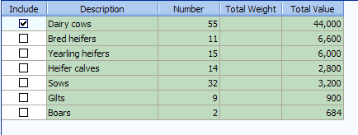

Note: You can also Select from previous entries for sales and cull sales if detail was used in the Other Farm Income page.

Born ~ For pig production enterprises, enter the number born alive.

Sold ~ The recommended conversion for pigs sold on a carcass weight basis is to convert to live weight based on a 75% yield if actual yield is unavailable. For cattle, use 62% yield.

- If you make gifts of livestock
On the Whole Farm Analysis - record value of gift as sale of livestock, and record same total as cash gifts given on Other Information input page.

On the Whole Farm w/Enterprise Analysis - handle same as whole farm, plus record as livestock produced and sold on the enterprise input pages.

Cull sales ~ Include all breeding animals sold here, even if they were shown in the “whole farm” input as sale of breeding stock instead of cull sales.

Transferred Out ~ Beef Cow/Calf calves to Backgrounding; Dairy heifer calves from Cows to Dairy Replacements; Dairy bull calves to Dairy Steers if not sold directly from dairy enterprise; Hogs - transferred to Breeding when farrowed - transferred out at weaning from Farrowing to Finishing if Finishing is separate.

- Note: When transferring calves from a Cow-Calf Enterprise to a Beef Background or Beef Feeder Enterprise – It is suggested that you charge 3% shrink value to the Cow-Calf Enterprise. This is done by reducing the transfer out value by 3%. This shrink cost will help the retained ownership enterprises reflect a more current analysis.

- Livestock butchered for home use:
On the Whole Farm Analysis - record the value of animal(s) butchered as sale of
animals, and record the same amount as family living expense.

On the Whole Farm w/Enterprise Analysis - handle the same as whole farm, plus
record on livestock enterprise page as “butchered.”

Product Sales and Other Income

Livestock Product Sales | Quantity | Value
Milk | Pounds | $
Wool | Pounds | $
Honey | Pounds | $
Eggs | Dozen | $

Milk ~ The quantity and value should be the milk produced during the analysis year. Use Detail and then the Select icon to select from whole farm entries.

Fed ~ Milk fed to calves

Government Payments ~ Include dairy MPP or other government payments (see previous CSP recommendations). Market Facilitation Program payment should also be entered as “Government Payments” on the Product Sales and Other Income table for the hog and dairy enterprises receiving a payment. Round 1 payments not yet received and Round 2 payments, if announced, will be entered as an account receivable on the balance sheet and should be distributed to the correct enterprises within enterprise analysis.

Other Income – Include livestock specific government payments and hedging gain or loss (enter negative). For Breeding Bulls (leased out) - split out as a separate enterprise and show lease income. Use Detail to document entries.

Other Information – Livestock

- Backgrounding/Growing and Finishing Enterprises must enter an average “daily” number of head on hand and a normal gain (if backgrounding from 500# to 750#, the normal gain/head is 250 lbs.) per head. Other information should be taken from livestock inventory matrix.

- Average number of head - The first item for each enterprise is the average number of livestock in the enterprise during the year. For growing and finishing livestock, this entry should be as close to a daily average as possible. For example, if 100 head of cattle were on the farm from January through March when they were sold and a new group of 200 was purchased on October 1, the average number would be 100 times one-fourth of a year plus 200 times one-fourth of a year or 75 head. The only place this number is used is to calculate the average daily gain on growing/finishing enterprises. (In some situations, it might make more sense to input normal gain/hd. as gross margin/net no. of heads/year.)

- Normal total gain per head -This item will not appear for all livestock enterprises. FINAN output for growing/finishing enterprises includes a Per Head column. To make the calculations for this column, FINAN must establish the number of head produced by the enterprise. So, FINAN will calculate the “number of head” by dividing this entry into the total pounds of gain for the enterprise to arrive at an approximation of the equivalent number of head that went through the enterprise. If you leave this entry blank, FINAN will use the number of head “sold” or “transferred” to make the calculation.

- Dairy ~ Required fields are Average Number of Cows and Barn Capacity. All other entries are optional for but will be included in the Historical Database and RankEm.

- Hogs ~ Live to carcass weight conversion factor will default to 75% if left blank.

Feed Fed

Use a conservative sales value for each feed fed. Refer to the 2018 FBMA Price Reference on the last page of this manual for reference prices.

See the input screen for proper units.
- Enter haylage and other wet forages in “as fed” form or enter the dry forage name and convert to dry equivalent at your discretion. If haylage is converted to dry hay, use the following formula:
  - (% dry matter of wet crop ÷ % dry matter of hay equivalent) * wet production
  - Example for converting 100 tons of haylage:
(.50 dry matter haylage ÷ .85 dry matter hay) * 100 = 58.8 tons
- See the discussion of AUMs under Crop Enterprise Analysis for pasture. Use the same value per unit for production of AUMs and feeding of AUMs.
- Convert high moisture corn to dry corn equivalent.
- Use the “Amount Remaining” column on the Feed Fed page and the “Crop and Feed Check” on the Accuracy Checks page in “preview” to assist in proving feed quantities.
- Be sure to use the correct units for each feedstuff (tons, lbs., etc.)

Direct Livestock Expenses

Direct Expenses ~ Enter total $ amount of each expense listed.
- Note – Any hired labor allocated to crops or livestock as a direct cost is subtracted from the total hired labor expense. The remainder is allocated as an overhead cost.

- Recommended allocation of manure application costs:
Dairy – 2/3 to livestock, remainder to crops
Hogs – 2/3 to crops, remainder to livestock

If detail is used on the Balance Sheets for prepaid livestock expenses and on the whole farm Direct Livestock Expense screen, then you can bring the information into the enterprise Direct Livestock Expense screen in FINAN using the Pick List. To do so, first click the Detail button. Then click the Select icon from the detail toolbar and check the expenses that belong to this enterprise. Beginning prepaids from the beginning balance sheet are shown as positive numbers, and ending prepaids from the ending balance sheet are shown as negative numbers. Current year direct livestock expenses from the whole farm screen show up at the top of the list followed by beginning and ending prepaids.

Allocated Livestock Expenses

If you have loaded the Missouri Setup, the top of the page will indicate that you are entering Percentages for livestock overhead cost allocations. For Percentages, enter the % of the total of each expense listed.

Default Allocations ~ Because of the wide variation in livestock operations, each producer should establish his own set of default percentages. They can then be adjusted from year to year and line by line as appropriate. This allocation percentage will be used for any expense that has no entry below.

- Note: The following tables show how FinPack calculates the “revenue adjustments” for the Cost of Production summary for each livestock enterprise output.

Livestock Cost of Production Revenue Adjustments
 | Breeding Lvst | Breeding Lvst | Breeding Lvst
 | Product Sale | Sale by Wgt | Sale by Carcass
 | (Dairy) | (Beef Cow-Calf) | (Farrow to Finish)
 | Cost of Prod Per | Cost of Prod | Cost of Prod
 | Cwt. of Milk Prod | Per Cwt. Produced | Per Cwt Carc Sold
Total cost
Beg inv br lvstk | Plus | Plus | Plus
Beg inv lvst hld sale | Plus
Purchases | Plus | Plus | Plus
Trans in | Plus | Plus | Plus
Sales | Minus
Cull sales | Minus | Minus | Minus
Butchered | Minus
Trans out | Minus
End inv br lvstk | Minus | Minus | Minus
End inv hld sale | Minus
Divide by | Prod + Used + Fed | Cwt Produced | Cwt Carcass Sold

Livestock Cost of Production Revenue Adjustments (cont.)
 | Breeding Lvst | Finishing Lvst | Finishing Lvst
 | Sale per Head | Sale by Wgt | Sale Per Head
 | (Farrow to Wean) | (Beef Finishing) | (Dairy Replace.)
 | Cost of Prod | Cost of Prod | Cost of Prod
 | Per Hd Sold/Trans | Per Cwt. Produced | Per Hd Sold/Trans
Total cost
Beg inv br lvstk | Plus | Plus | Plus
Beg inv lvst hld sale |  | Plus | Plus
Purchases | Plus | Plus | Plus
Trans in | Plus | Plus | Plus
Sales
Cull sales | Minus | Minus | Minus
Butchered |  | Minus | Minus
Trans out
End inv br lvstk | Minus | Minus | Minus
End inv hld sale |  | Minus | Minus
Divide by | Head Sold/Trans | Cwt Sold/Trans | Head Sold/Trans
Value Added/NonFarm Analysis

Use the Value Added/Nonfarm Enterprise Analysis to analyze value added co-op investments, custom work, and nonfarm enterprises such as trucking and seed sales.

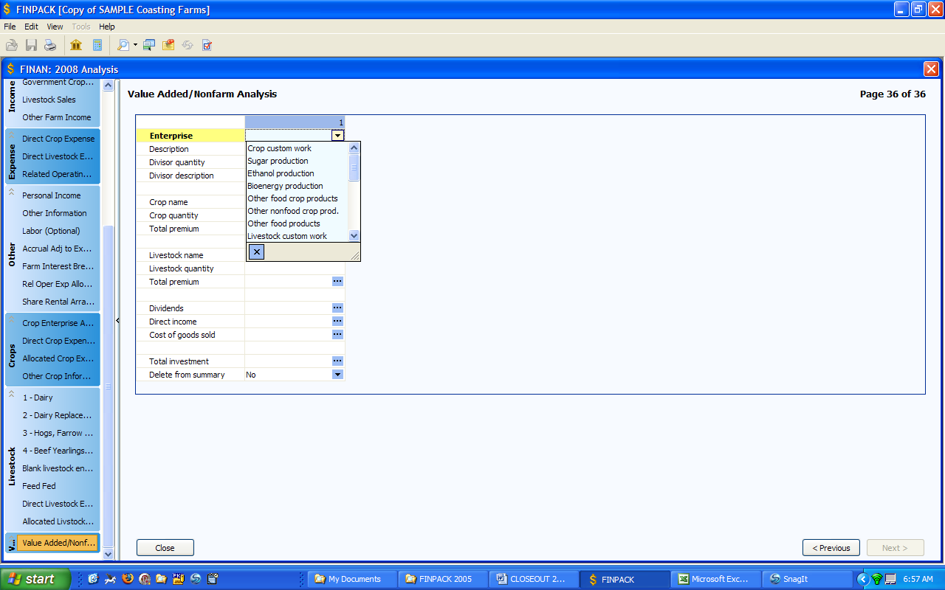

Enterprise ~ Select the enterprise type from the drop down list. This will only be used to sort enterprises for group summaries.

Divisor quantity and description ~ If it is useful, use this as a custom divisor for the output report. Do not use for crop or livestock units used in the enterprise – this will be included under the crop and livestock entries. The divisor description will be used in the column heading. Examples, miles for trucking, shares for co-op investments.

Crop Related Enterprises ~ If you want to analyze this enterprise based on the number of units of a crop used, enter the crop name and the number of units used/marketed. Also, if the easiest way to measure the income from this enterprise is to calculate the premium price received for the crop, enter the Total Premium income received over the price used to value the crop in the crop enterprise analysis.

Livestock Related Enterprises ~ If you want to analyze this enterprise based on the number of units of a livestock enterprise used, enter the enterprise name and the number of units used/marketed. Also, if the easiest way to measure the income from this enterprise is to calculate the premium price received for the livestock, enter the Total Premium income received over the price entered for sales of from this enterprise in the livestock enterprise analysis.

Dividends and Direct Income ~ Enter any other income for the enterprise. All income for the enterprise must be entered in Crop Premium, Livestock Premium, Dividends, and Direct Income.

Cost of Goods Sold ~ Optional, use this only if the enterprise has an identifiable cost of goods sold as would be entered on Schedule C for this enterprise.

Total Investment ~ This will be used to calculate the Rate of Return on Assets for this enterprise.

Direct Expense ~ This is the IRS Schedule C expense list. Enter all expenses except the cost of goods sold and those allocated from the farm expenses.

Allocated Expenses ~ Enter the percentage of the Value Added/Nonfarm allocated expenses to each enterprise.

DOWNLOADING FINPACK SETUP FILES

FINPACK Setup Files for Missouri are available for downloading from the Center For Farm Financial Management web site. This will insure a consistent chart of accounts is used for all farms. You should install the setup for your group on each computer that will be used for analysis.

Once on the website, follow the steps to download and setup your software.

Download the FINPACK setup for your region by:

1. Go to: http://www.cffm.umn.edu/

- Select Publications + Educator FINPACK Setups

- Click Start Download

4. Save FPUniformSetup.exe to your computer and run it

5. Select your group from the State/Region drop-down list

6. Follow the steps to finish the setup installation

IMPORTING FINAN DATA

Exporting From Accounting Software

FINPACK interfaces exist for several accounting software packages including Quickbooks, Quicken, EasyFarm, PCMars, UltraFarm, and MicroTel. Each system will export the cash transactions for the period in a file format that can be imported into FINAN. At this time, only cash transactions are included. Most systems export totals for each chart of accounts category.

The exported file will have a file extension of ‘.fif’ (FINPACK Interface File). If the export file does not include this extension, rename the file to add the .fif extension. Refer to the individual accounting system documentation for instructions on exporting data for
FINPACK.

Selecting The FinPack Interface File

Begin by creating your FINAN for the accounting period, either by creating a blank FINAN or copying last year’s analysis. On the FINAN General Information page, select the beginning and ending balance sheets (balance sheet data is not imported). Then select Edit + Import Data from the main menu.

You will be prompted for the file location. If the correct file name for this farm is not displayed, click Browse to find the correct file.

The default setting is to delete all existing cash transaction data from the FINAN input. If you uncheck this option, imported transactions will be added to existing transactions. This may be useful for farms that keep more than one set of accounts.

Checking and Correcting Data Mapping

When the FINPACK Interface File is selected, the data will be displayed by category and chart of accounts location as shown below. At this point you have the ability to check and edit the destination of the imported data in FINAN. Scroll through the FINAN data entry page titles on the left to review and edit the data mapping.

Column 1: Category – This is the FINAN Whole Farm data entry category destination for the transaction data. The category can be changed to move data to a different location in FINAN. If the new category moves the data to a different page, the record will disappear from the current category listing once you move to a different record (as it is moved to the new page).

Column 2: This is the chart of accounts destination for each transaction. The major purpose of this page is to allow you to change the destination to accurately import the transaction data into FINAN.

Column 3: Description – This is the description of the account from the accounting software.

Column 4: Value – This is the dollar amount that will be imported. Values can be changed here in the unusual situation that a correction is needed. Value changes are temporary until the data is imported or the import is Cancelled; changes are not saved in the ‘.fif’ file. When you have verified the data mapping for each page of FINAN data entry, click OK. When the data has been successfully imported, the FINAN will close and you will need to re-open it to view and edit the FINAN data.

Importing Errors

If errors are found in the import file, an error message will be displayed and specific amounts will not be imported. Errors usually indicate that the chart of accounts being mapped to in FINAN is not active in your copy of FINPACK. You will have to manually enter these amounts in FINAN to correct the problem.
Farm Business Management Analysis (FinPack™)
References:
Weekly Market Summary (Mo Grain Weekly Trends) – Missouri Department of Agriculture, P.O. Box 630, Jefferson City, MO 65102
Missouri Crop & Livestock Reporter (Average Prices Received by Farmers) - MO Ag Statistics, P.O. Box L, Columbia, MO 65205

Average Missouri Selling Prices for Reference “FEED FED” for Livestock Enterprising
Calculated from “MO Crop & Livestock Reporter” (January-November)
and “Weekly Market Summary” (November - partial December)

KIND OF FEED 2011 2012 2013 2014 2015 2016 2017 2018
corn, bu 6.24 6.86 6.45 4.17 3.69 3.50 3.40 3.57
soybeans, bu 12.61 14.36 14.22 12.64 9.56 9.58 9.47 9.27
wheat, bu 6.52 7.16 6.83 5.79 4.39 3.90 4.19 4.90
pasture day .40 .40 .40 .40 .40 .40 .40 .40
milo, bu 6.18 6.40 6.12 4.18 3.89 3.20 3.11 3.41
pasture, AUM 12.00 12.00 12.00 12.00 12.00 12.00 12.00 12.00
hay/grass, ton 60.00 60.00 60.00 60.00 60.00 60.00 60.00 90.00

Reference Prices for "CROP VALUE per Unit/ACRE - CASH”
Average Missouri selling price of crop at harvest calculated from “Weekly Market Summary” and “MO Crop & Livestock Reporter” data. Corn, soybean, and milo prices calculated from September-November. Wheat prices calculated from June-July.

2011 2012 2013 2014 2015 2016 2017 2018
corn, bu 6.12 7.33 4.65 3.30 3.68 3.20 3.18 3.54
soybeans, bu 11.88 14.90 13.00 10.40 8.94 9.52 9.25 8.56
wheat, bu 6.64 6.82 6.70 5.44 4.53 4.12 4.47 4.90
milo, bu 6.30 6.83 4.44 3.26 3.83 2.82 2.96 3.38
pasture, AUM 12.00 12.00 12.00 12.00 12.00 12.00 12.00 12.00

REFERENCE PRICES FOR END OF YEAR Inventory “CROP” Values
Source - “Weekly Market Summary - Missouri Grains Weekly Trends,” January 4, 2019

 | 2015 | 2015 | 2015 | 2016 | 2016 | 2016 | 2017 | 2017 | 2017 | 2018 | 2018 | 2018
 | (KC) | (StL) | (C) | (KC) | (StL) | (C) | (KC) | (StL) | (C) | (KC) | (StL) | (C)
corn | 3.61 | 3.67 | 3.47 | 3.39 | 3.67 | 3.12 | 3.31 | 3.57 | 3.20 | 3.71 | 3.79 | 3.46
soybeans | 8.69 | 8.97 | 8.44 | 9.52 | 10.15 | 9.42 | 9.15 | 9.64 | 9.02 | 8.45 | 8.74 | 8.18
wheat | 2.95 | 4.20 | 4.34 | 3.41 | 4.03 | 3.18 | 3.70 | 4.32 | 3.47 | 4.75 | 5.36 | 4.49
milo, bu | n/a | 3.33 | 3.09 | 2.97 | 2.92 | n/a | 3.41 | 3.47 | n/a | 3.25 | 4.00 | n/a

